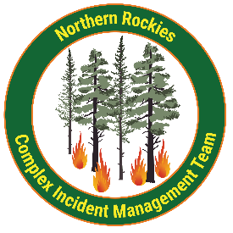
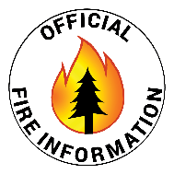
Johnson, Sharrott Creek,

Daly, and Railroad Fires
Bitterroot National Forest
https://linktr.ee/sharrottjohnsondalyrailroad
September 17, 2024
Northern Rockies Team 5, Incident Commander Joe Sampson

Fire Cause Size Completion Phone # Personnel
Johnson Lightning 6,687 46% 406-401-0286 81
Sharrott Creek Lightning 3,204 83% 406-403-7976 216
Daly Undetermined 6,813 38% 406-403-7971 26
Railroad Undetermined 1,006 35% 406-403-7971 (shared with Daly)

The area closures surrounding the fires are still in effect. These closures are necessary to protect the safety and welfare of the public and provide for safe firefighter and equipment operations and access. Fire managers are working in conjunction with Bitterroot National Forest officials to assess the need and potential boundary changes.

All three incidents are downsizing as resources demobilize due to increased moisture and limited fire activity.

Current Status
Johnson (3 miles south of Springer Memorial Community, in the East Fork)
Firefighters continue to work alongside resource advisors from the Bitterroot National Forest to implement suppression repair efforts using excavators and hand tools to pull back berms on constructed firelines.

Sharrott (3 miles west of Stevensville)
Firefighters and excavators continue to implement suppression repair efforts to pull back berms on constructed firelines on the northern and southern firelines. Wood chippers work to break down large branches and tree trunks into smaller pieces, scattering available fuels alongside the constructed fireline. Fire activity is minimal due to the increased precipitation across the fire area.

Daly and Railroad (Railroad and Skalkaho Creeks confluence, 26 miles southeast of Hamilton)
Minimal fire activity is present, with no expected spread on the Railroad and Daly Fires. Crews will continue with hazard mitigation along the Skalkaho Highway (Highway 38).

Weather and Fire Behavior
The weather Tuesday will remain unstable with a widespread wetting rain expected. High temperatures will be in the low 60s. The minimum relative humidity will be around 70%. Winds will be mostly terrain driven around 5-10 mph, gusting 20-25 mph out of the west in the evening.

Fire behavior will be creeping and smoldering, primarily in stump holes, large logs, and accumulated fuels.

EVACUATIONS, RESTRICTIONS, CLOSURES
- Area closures are still in effect for all fire areas. More information on Bitterroot National Forest area closures can be found at: https://www.fs.usda.gov/alerts/bitterroot/alerts-notices

